
Unit 7 - Quiz 1

Name & Surname | : .......................................................... | Class | : .......................................................
Student ID Number | : .......................................................... | Date | : .......................................................
School | : .......................................................... | Result | : .......................................................

READING

- Read the text and write T for True or F for False. (1 x 10 = 10)



Andy is eighteen and she is a successful student at university. She’s studying medicine. One day, she’ll be a famous doctor. She wants to help all sick people and find the cure for cancer. She is planning to travel all around the world when she becomes famous and rich. She hopes to have a large house and a luxury car.

-  Andy is a doctor now.

- She is studying engineering.

- She will be a nurse in the future.

- One of her future plans is being rich.

- She will have 2 children in 2025.

- She wants to help sick people.

- She has a car now.

- When she graduate from university, she will be a doctor.

- She will travel around the world when she becomes famous and rich.

- She has a large house now.

- Tick Andy’s future plans. (2 x 4 = 8)
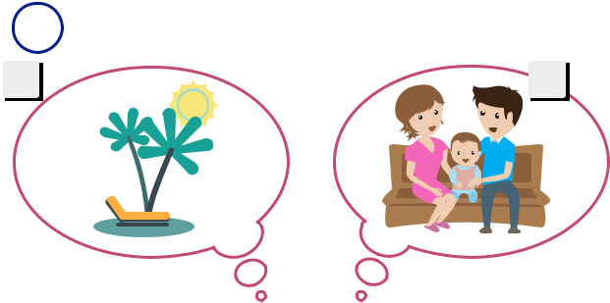

1 2
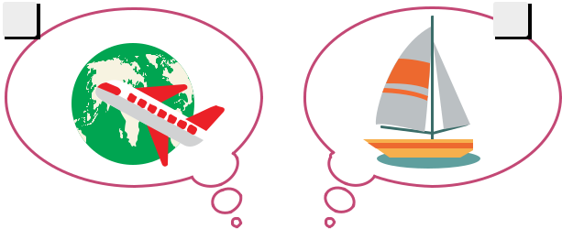

3 4
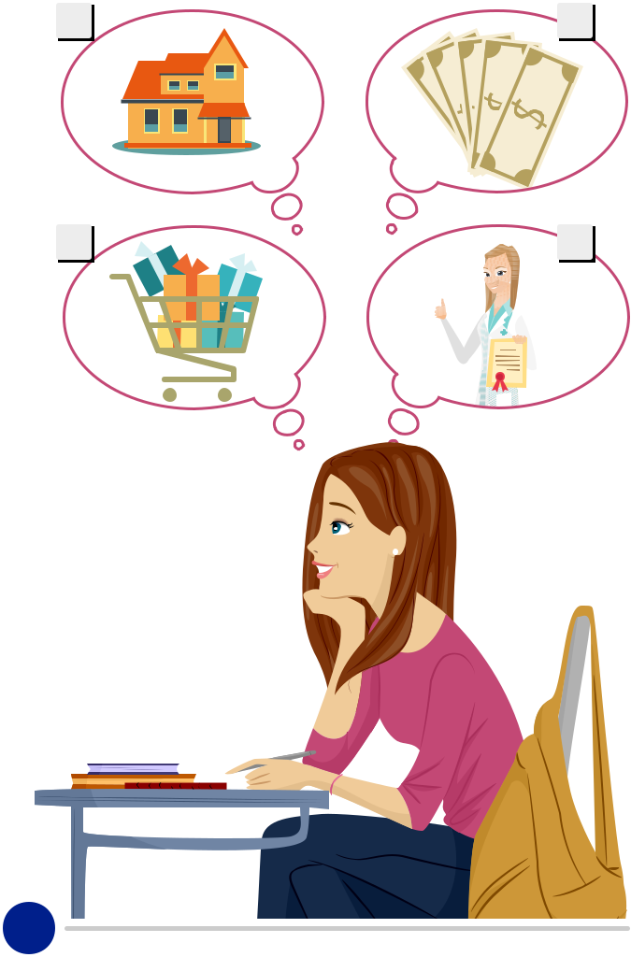

5 6

7 8

Andy

1

GRAMMAR

- Use “will” or “won’t” to fill in the blanks. (1 x 8 = 8)

1 | I’m studying engineering, I .................. be an
 | engineer.
2 | It’s hot, I .................. wear a sweater today.
3 | I am never late. I .................. be there on time.
4 | It’s sunny. I .................. take an umbrella with
 | me.

5 | He knows I’m coming. It .................. be a surprise
 | for her.
6 | Don’t worry! I .................. be there on time.
7 | Look at the nice weather. It .................. be a
 | sunny day.
8 | I’m sorry, but I .................. accept your offer.

- Rewrite the questions. (4 x 7 = 28)

- What / dream / her / for the future/ is

........................................................................................................................................ ?

- get married / you / will / When

........................................................................................................................................ ?

- will / Who / visit / tomorrow / us

........................................................................................................................................ ?

- at home / will / Why / you / stay / all day

........................................................................................................................................ ?

- plans / your / What / future / are

........................................................................................................................................ ?

- rich / Will / in the future / you / be

........................................................................................................................................ ?

- from / will / graduate / you / When / university

........................................................................................................................................ ?

- Match the answers with the questions in B. (2 x 7 = 14)

- Uncle Ted.



b |  | Yes, I will.
c |  | She wants to be famous in the future.
d |  | In 2026.
e |  | I will be a pop star.
f |  | I will get married in 5 years.
g |  | Because I will study for my final exams.


2

- Circle the suitable time expressions for the given sentences. (2 x 6 = 12)

- I will be in Paris in 2004 / 2024.

- We won’t be here tomorrow / yesterday.

- I will be thirty-nine years old ten years later / ten years ago.

- I will study math last night / tonight.

- I think it will rain in ten minutes / five minutes before.

- There will be a sky scraper here in the past / the future.

VOCABULARY

- Complete the sentences with the words given. (2 x 10 = 20)

»» | go | »» | wear | »» | buy | »» | move | »» | abroad
»» | use | »» | be | »» | read | »» | become | »» | fly

1 | In 2020 I will .......................... a brand new
 | car.
2 | I will study university ..........................
 | because I want to learn English in an English
 | speaking country.
3 | We will .......................... very happy in İzmir.
4 | I think new generation electricity cars will
 | .......................... very popular.
5 | I’m too tired to cook, so we will
 | .......................... to a restaurant.

6 | One day, I want to .......................... to New
 | York City.
7 | People will .......................... robots for
 | housework.
8 | Children will .......................... digital books
 | mostly.
9 | People will .......................... technological
 | clothes.
10 | Cars will .......................... in the future.

GOOD LUCK !

3

