**MATCH THE PICTURES WITH THE ACTIVITY NAMES**

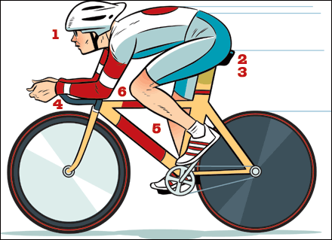 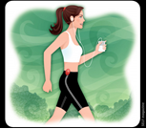  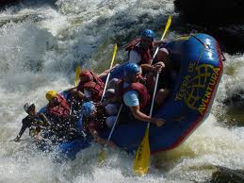

_________________ _________________ _____________ _______________

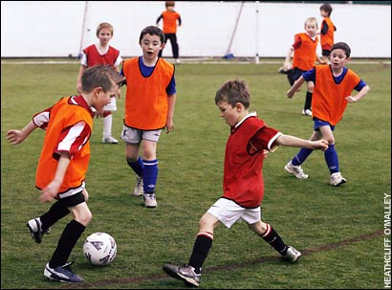 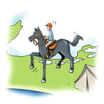 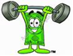 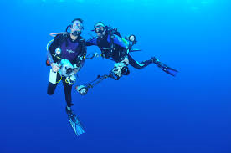

______________ __________________ _________________ ____________________

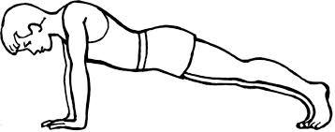 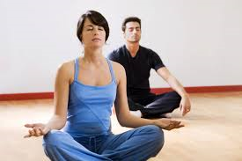 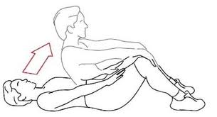 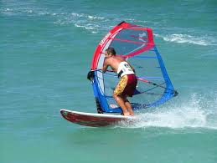

________________ _______________ ______________

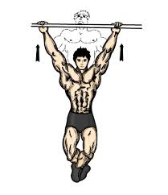 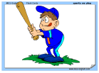 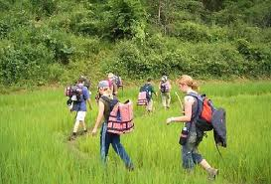 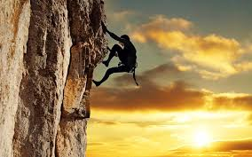

________________ _______________ __________________ ____________________

**windsurfing weight-lifting golf yoga swimming sit-ups skating**

**chin-ups cycling jogging trekking horse-riding Push-ups rafting climbing baseball**